**CS263-Web Technology Lab Cycle**

**HTML**

1. a. Create a table to show your class timetable.

<!DOCTYPE html>

<html>

<head>

<title>II/IV th B.tech., timetable(R20)-R.V.R. & J.C. College Of Engineering</title>

</head>

<style>

table, th, td {

border:1px solid black;

}

</style>

<body>

<table style="width:100%;">

<tr>

<th>DAY </th>

<th>8:00-9:00 </th>

<th>9:00-10:00 </th>

<th>10:00-11:00</th>

<th>11:00-12:00</th>

</tr>

<tr>

<td>MON </td>

<td>WT </td>

<td>DBMS</td>

<td>OS</td>

<th>SE</th>

</tr>

<tr>

<td>TUE </td>

<td>SE</td>

<td>OS</td>

<td>CS</td>

<th>SOC</th>

</tr>

<tr>

<td>WED </td>

<td>OS </td>

<td>SE</td>

<td>DBMS</td>

<th>WT</th>

</tr>

<tr>

<td>THU </td>

<td>OS </td>

<td>CS</td>

<td>WT</td>

<th>E&HV</th>

</tr>

<tr>

<td>FRI </td>

<td>DBMS </td>

<td>SE</td>

<td>OS</td>

<th>CS</th>

</tr>

<tr>

<td>SAT </td>

<td>CS </td>

<td>WT</td>

<td>DBMS</td>

<th>SE</th>

</tr>

</table>

</body>

</html>

**OUTPUT:**

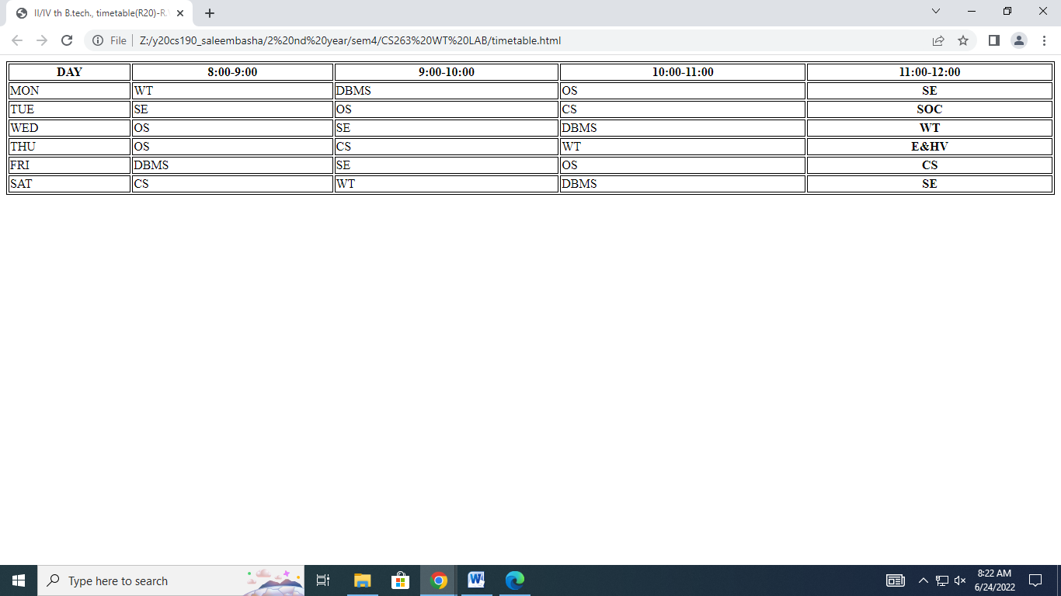

**b. Use tables to provide layout to your HTML page describing your college infrastructure.**

<!DOCTYPE html>

<html>

<head>

<title>R.V.R. & J.C.College of Engineering Infrastructure</title>

</head>

<body>

<h1 style="color:green;text-align:center">

R.V.R. & J.C.College of Engineering Infrastructure

</h1>

<center><table height="100%" width="100%">

<tr >

<td style="width:600px;background-color:lightgreen;">

<h1><u>courses</u></h1>

<h2>B.Tech.,<h2>

<h4>1. Chemical Engineering<br>

2. Civil Engineering<br>

3. Computer Science & Business Systems<br>

4. Computer Science & Engineering<br>

5. Computer Science & Engineering (Artificial Intelligence & Machine Learning)<br>

6. Computer Science & Engineering (Data Science)<br>

7. Computer Science & Engineering (Internet of Things)<br>

8. Electrical & Electronics Engineering<br>

9. Electronics & Communication Engineering<br>

10. Information Technology<br>

11. Mechanical Engineering</h4>

<h2>M.Tech<br>

MBA<br>

MCA<br>

</h2>

</td>

<td style="background-color:yellow;">

<h1><u>facilities<br></u></h1>

<h3>1.Central Library.<br>

2.Departmental Library.<br>

3.Men's Hostel.<br>

4.Girl's Hostel.<br>

5.Canteen.<br>

6.Medical Facilities.<br>

7.Open Air Theater.<br>

8.NCC.<br>

9.NSS.<br>

10.Computer Centers.<br>

11.E-Classroom.<br>

12.Stores.<br>

13.Seminar Halls.<br>

14.Sports.<br>

</h3>

<br>

<br>

<br>

<br>

</td>

<td style="background-color:pink;">

<h1><u>Buildings<br></u></h1>

<h3>1.Cyber Block.<br>

2.Digital Block.<br>

3.Hi-Tech Block.<br>

4.Main Block.<br>

5.Decinal Block.<br>

6.Silver Jubilee Block.<br>

<br>

<br>

<br>

<br>

<br>

<br>

<br>

<br>

<br>

<br>

<br>

</h3>

</td>

</tr>

</center></table>

</body>

</html>

**OUTPUT:**

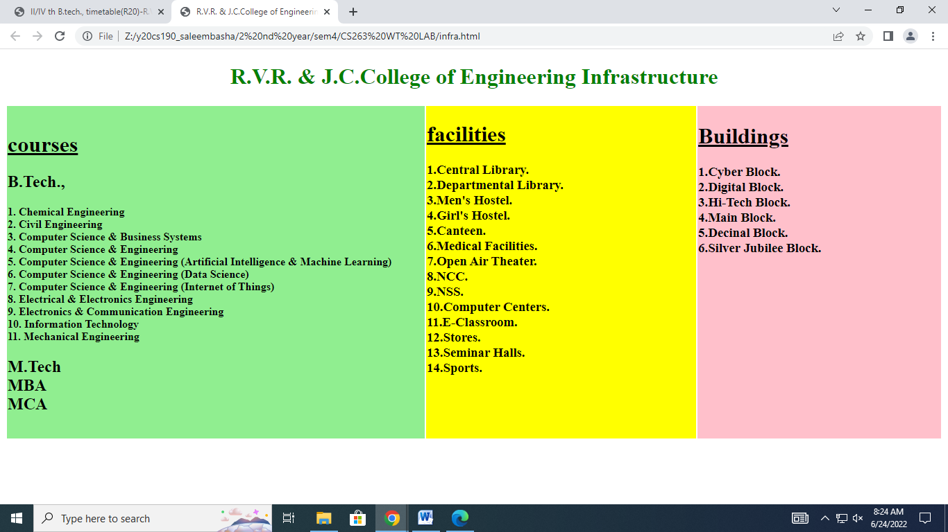

1. **a. Use frames such that page is divided into 3 frames 20% on left to show contents of pages, 60% in center to show body of page, remaining on right to show remarks.**

**b. Embed Audio and Video into your HTML web page.**

<!DOCTYPE html>

<html>

<frameset cols="20%,60%,20%" frameboarder="yes" boarder="3" boardercolor="lightgreen">

<frame src="tab.htm" name="left">

<frame src="body.htm" name="center" >

<frame src="remark.htm" name="right">

</frameset>

</html>

<!--this is body.html code-->

<!DOCTYPE html>

<html>

<body>

<h1>Welcome!</h1>

<p><strong>This is the main webpage which will display information about different departments in R.V.R. & J.C. College of Engineering.Click on any link from left side to know more about respective department!</strong></p>

</body>

</html>

<!-- this is remark.html code-->

<!DOCTYPE html>

<html>

<body style="background-color:skyblue;">

<h1>Remarks</h1>

<p>Please give your remarks!(if any,)</p>

<table>

<tr><td>________________________________</td></tr>

<tr><td>________________________________</td></tr>

<tr><td>________________________________</td></tr>

<tr><td>________________________________</td></tr>

<tr><td>________________________________</td></tr>

<tr><td>________________________________</td></tr>

<tr><td>________________________________</td></tr>

<tr><td>________________________________</td></tr>

<tr>

<td> <h1>Audio<br></h1>

<strong style="color:darkgreen;">Jai ho song from slumdog millionaire movie<br></strong>

<br>

<br>

<audio controls>

<source src="C:/Users/sbash/Downloads/13. Jai Ho.mp3" type="audio/mp3">

</audio></td></tr>

</table>

</body>

<!html>

<!-- this is tab.html code-->

<!DOCTYPE html>

<html>

<body style="background-color:lightgreen;">

<table>

<tr >

<td><h1>contents</h1>

<a href="http://cse.rvrjcce.ac.in/" target="center" style="color:red;">1.Computer Science & Engineering<br></a><br>

<a href="http://csbs.rvrjcce.ac.in/" target="center" style="color:red;">2.Computer Science & Business Systems<br></a><br>

<a href="http://it.rvrjcce.ac.in/" target="center" style="color:red;">3.Information Technology<br></a><br>

<a href="http://www.rvrjcce.ac.in/Electrical/" target="center" style="color:red;">4.Electrical & Electronics Engineering<br></a><br>

<a href="http://ece.rvrjcce.ac.in/" target="center" style="color:red;">5.Electronics & Communication Engineering</a><br>

</td>

</tr>

<tr>

<td><h1>Videos<br></h1>

<strong style="color:red">College ArialView</strong>

<video width="320" height="240" controls>

<source src="https://rvrjcce.ac.in/home_gallery/arialview.mp4" type="video/mp4">

</video>

</td>

</tr>

</table>

</body>

</html>

**OUTPUT:**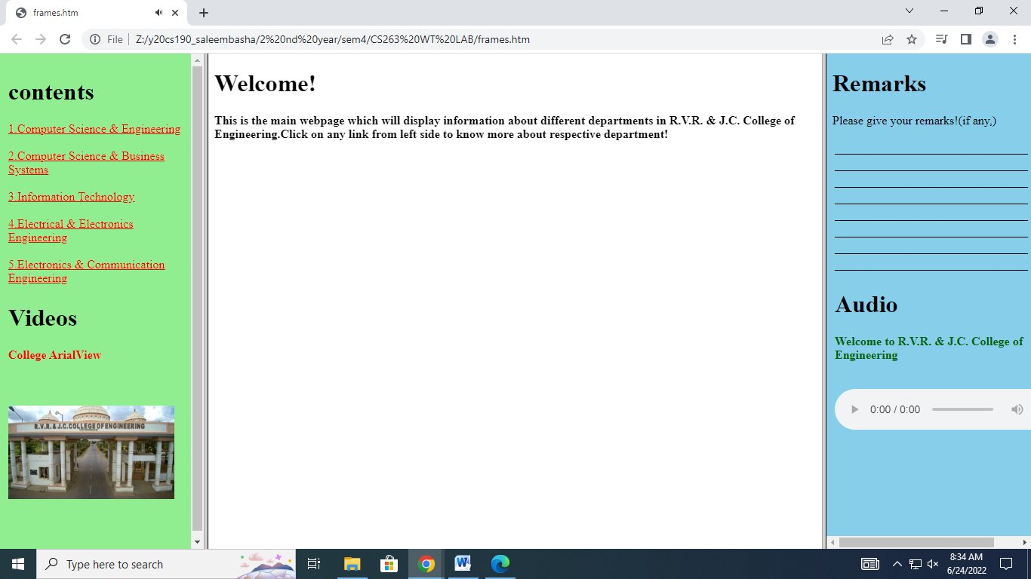

**3. a. Create a webpage with HTML describing your department use paragraph and list tags.**

**b. Apply various colors to suitably distinguish key words, also apply font styling like italics, underline and two other fonts to words you find appropriate, also use header tags. c. Create links on the words e.g. ―Wi-Fi and ―LAN‖ to link them to Wikipedia pages.**

**d. Insert an image and create a link such that clicking on image takes user to other page.**

**e. Change the background color of the page; at the bottom create a link to take user to the top of the page.**

<!DOCTYPE html>

<html style="scroll-behavior:smooth;">

<head>

<title>About CSE department of R.V.R. & J.C. College of Engineering</title>

</head>

<body style="background-color: lightpink;">

<h1 style="text-align:center;">About CSE department of R.V.R. & J.C. College of Engineering</h1>

<p style="color:green;"><i>

1.Accreditation.</i>

<ul><li>Accredited by NBA, AICTE in the year 2021.</li><li>Accredited by NBA, AICTE in the year 2017.</li><li>Accredited by NBA, AICTE in the year 2012.</li></ul>

</p>

<p style="color:blue;">

<u>2.Department Achievements.</u>

<ul>

<li style="font-family:verdana;">Received grant under scheme of MODROBS Rs.11,56,863/- from AICTE, New Delhi for "Modernization of Machine Learning Laboratory" in 2019-20.</li>

<li style="font-family:courier;">Received grant under scheme of STTP Rs.2,58,000/- from AICTE, New Delhi for "STTP on Multicore Architectures and Programming" in 2019-20.</li>

<li>The department has established a ROBOTICS laboratory (e-Yantra) with partial funding (approximately 1, 00,000/- rupees worth of equipment) from IIT Bombay under the scheme NMEICT, MHRD.</li>

<li>A total of 9 faculty members have been selected as top performers by attending the AICTE approved FDP on "Use of ICT in Education for online and Blended Learning" received CSE-SAP cash award Rs 5000/- each along with certificate of excellence from IIT Bombayx.</li>

<li>A-View class room setup- IIT Bombay Remote center sanctioned an amount of 2,80,000/- lakhs by NMEICT, MHRD Government of India.</li>

</ul>

</p>

<p style="color:red;">

3.Faculty Achievements

<ul>

<li><a href="http://cse.rvrjcce.ac.in/Phd_service.pdf">Ph.D Awarded in Service</a></li>

<li><a href="http://cse.rvrjcce.ac.in/phd_registered_20.pdf">Ph.D Registered</a></li>

<li><a href="http://cse.rvrjcce.ac.in/patents-cse.php">Patents Filed/Published</a></li>

<li><a href="http://cse.rvrjcce.ac.in/phd_scholarsn.pdf">Research Supervisors</a></li>

<li><a href="http://cse.rvrjcce.ac.in/toppiit.pdf">IIT Bombay Top Performers</a></li>

<li><a href="http://cse.rvrjcce.ac.in/Top_Performers_Nptel_2021.pdf">NPTEL Top Performing Mentors</a></li>

<li><a href="http://cse.rvrjcce.ac.in/bos.pdf">BOS Members</a></li>

<li><a href="http://cse.rvrjcce.ac.in/OnlineCoursesdonebyFaculty2021u.pdf">Courses Done</a></li>

</p>

<a href="https://en.wikipedia.org/wiki/Local_area_network"> Click here to know about LAN<br></a>

<a href="https://en.wikipedia.org/wiki/Wi-Fi">Click here to know about WI-FI</a>

<p>click on below image to goto R.V.R. & J.C. College of Engineering website</p>

<a href="https://rvrjcce.ac.in/"><img src="C:\Users\y20cs190\Downloads\download.jfif" alt="Loading RVR & JCCE website please wait" height="170" width="100"><br></a>

<a href="#top">click here to goto TOP</a>

</body>

</html>

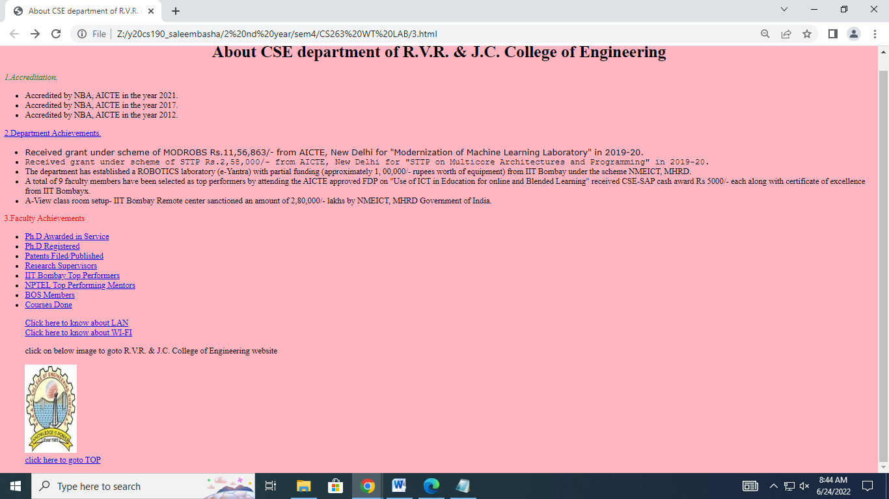

**4.Develop static pages (using only HTML) of an online book store, the pages should resemble: www.amazon.com, the website should consist the following pages, home page, registration and user login, user profile page, books catalog, shopping cart, payment by credit card, order confirmation.**

<!DOCTYPE html>

<html>

<frameset rows="20%,10%,70%" bordercolor="white">

<frameset cols="20%,70%,10%" bordercolor="white" frameborder="yes" border="0.5">

<frame src="logo.htm">

<frame src="name.htm">

<frame src="cart.htm">

</frameset>

<frame src="menu.htm">

<frameset cols="20%,80%">

<frame src="body1.htm">

<frame src="empty.htm" name="empty">

</frameset>

</frameset>

</html>

**Output:**



<!-- this is logo.htm code - - >

<!DOCTYPE html>

<html>

<head>

<style>

body

{

background-image: url('logo.jpg');

background-repeat: no-repeat;

background-attachment: fixed;

background-size: 100% 100%;

}

</style>

</head>

<body>

</body>

</html>

**Output:**



<!-- this is name.htm code - - >

<!DOCTYPE html>

<html>

<head>

<style>

body

{

background-image: url('background.jpg');

background-repeat: no-repeat;

background-attachment: fixed;

background-size: cover;

}

h1

{

font-size:300%;

color:yellow;

}

</style>

</head>

<body>

<h1><center>MS BookShop & Communications</center></h1>

</body>

</html>

**Output:**



<!-- this is code for cart.htm - - >

<!DOCTYPE html>

<html>

<head>

<style>

b

{

font-size:200%;

}

img

{

height: 100%;

width: 60%;

}

</style>

</head>

<body>

<a href="mess.htm" target="empty"><img src="cart.jpg" alt="loading..."><center><b>cart</b></center></a>

</body>

</html>

**output:**



**< ! - - when you click on the cart image or cart text the following is output - - >**

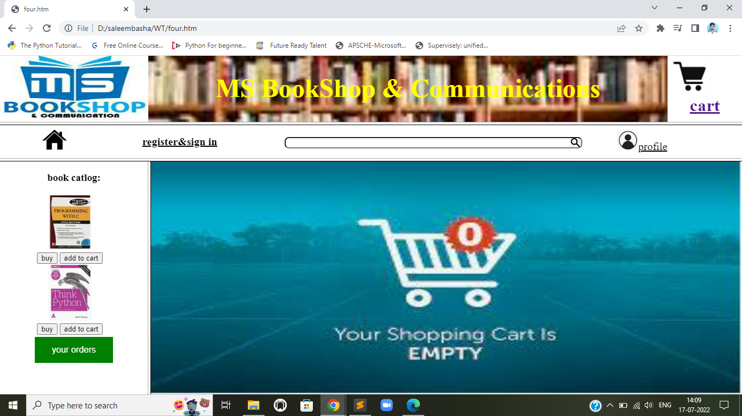

**<! - - the code for above output is (i,e., mess.htm code) - - >**

**<!DOCTYPE html>**

**<html>**

**<head>**

**<style>**

**body**

**{**

**background-image: url('empty.jpg');**

**background-repeat: no-repeat;**

**background-attachment: fixed;**

**background-size: 100% 100%;**

**}**

**</style>**

**</head>**

**<body>**

**</body>**

**</html>**

**< ! - - code for menu.htm - - >**

**<!DOCTYPE html>**

**<html>**

**<head>**

**<style>**

**a,div{**

**display: inline-block;**

**color: black;**

**}**

**div{**

**font-size:20px;**

**}**

**.pad{**

**margin-right: 100px;**

**display: inline-block;**

**}**

**.text1{**

**background-image: url(search.png);**

**background-position: right;**

**background-repeat: no-repeat;**

**border-radius: 8px;**

**background-size: 20px;**

**}**

**</style>**

**</head>**

**<body>**

**<a href="four.htm" target="_parent" title="home" style="padding-left: 70px;"><img src="home.png" width="25%"></a>**

**<div class="pad">**

**<a href="signin.htm" target="_parent">**

**<b style = "position:relative;bottom:10px;">register&sign in</b>**

**</a>**

**</div>**

**<div style = "position:relative;bottom:10px;">**

**<form style="padding-left: 20px;padding-right: 10px">**

**<input type="text" class="text1" style="width: 540px;">**

**</form>**

**</div>**

**<div>**

**<a href="profile.htm" target="_parent" title="profile" style="padding-left: 50px;">**

**<img src="profile.png" width="25%">profile</a>**

**</div>**

**</body>**

**</html>**

**output:**

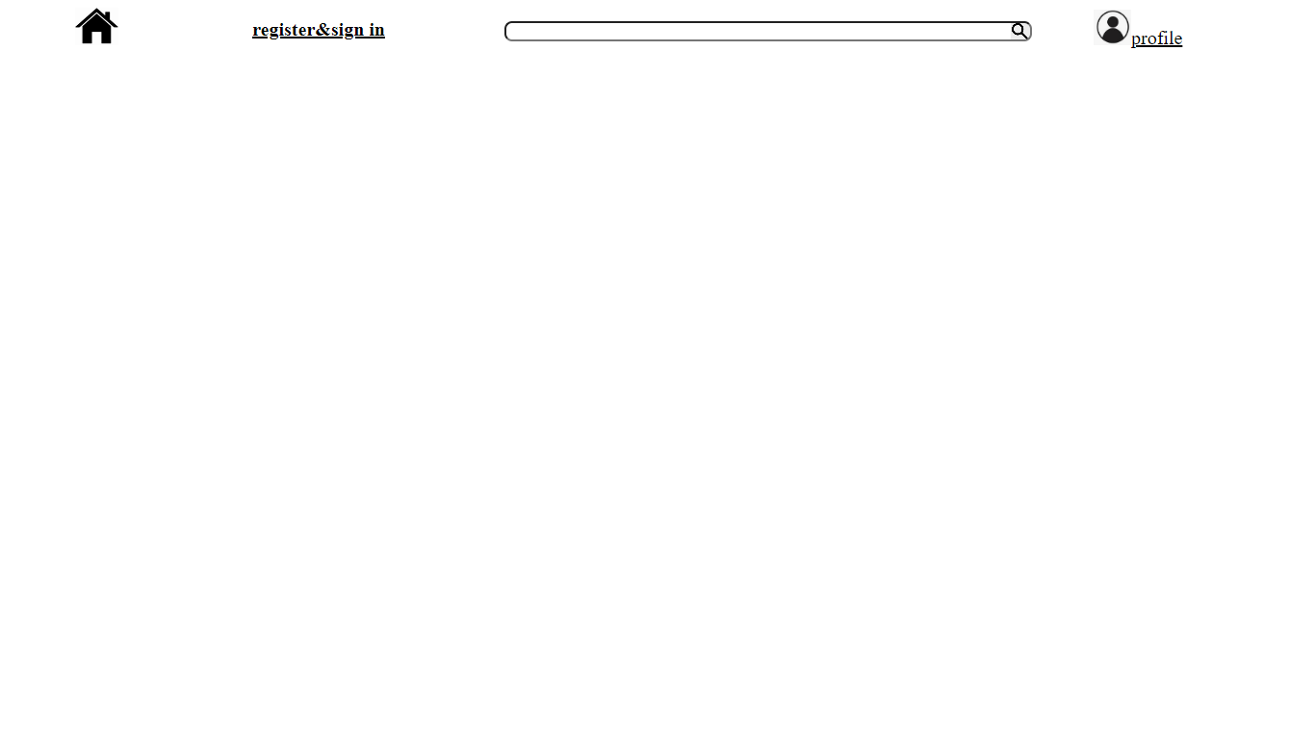

**< ! - - when we click on home image the output is - - >**



< ! - - when you click on register& sign in the output is: - - >

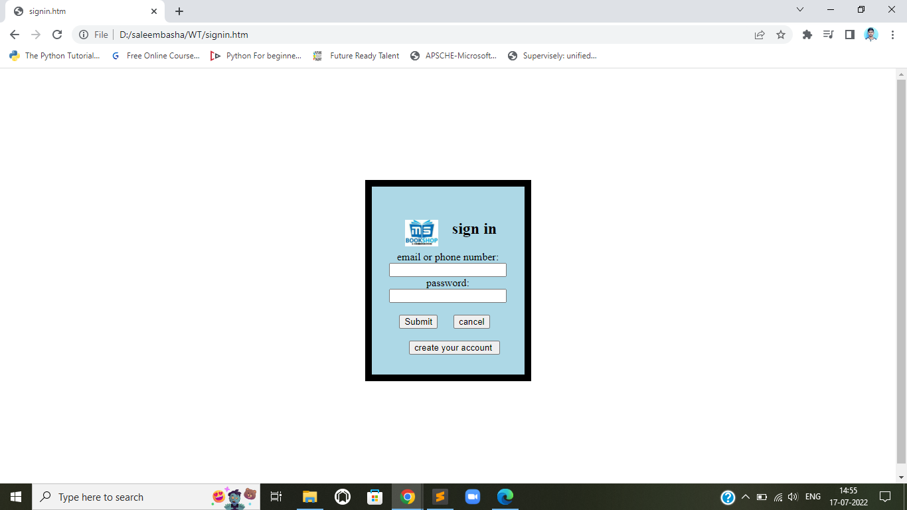

< ! - - code for above output - - >

<!DOCTYPE html>

<html>

<head>

<style>

body{

<!--padding-left: 590px;-->

padding-top: 100px;

}

.bor{

border: 10px solid black;

padding: 30px 20px;

width: 250px;

background-color: lightblue;

box-sizing: border-box;

}

.pad{

padding-left: 10px;

}

.pad_a{

padding-left: 10px;

}

.image{

padding-left: 30px;

float: left;

}

</style>

</head>

<body>

<center style="padding: 160px 5px">

<div class="bor" >

<center>

<img class="image" src="logo.jpg" width="50px" >

<h2 style="text-align: center;">sign in</h2>

<form>

<label style="text-align:left;">email or phone number:</label><br>

<input type="text"><br>

<label style="text-align:left;">password:</label><br>

<input type="text"><br><br>

<div class="pad"><input type="submit" style="margin-right: 20px;">

<input type="button" value="cancel" style="margin-right: 20px;"><br><br>

<div class="pad_a"><input style="padding-right: 10px; " type="button" value="create your account"></div>

</form>

</center>

</div>

</center>

</body>

</html>

< ! - - when you click on the profile image or text the output is: - - >

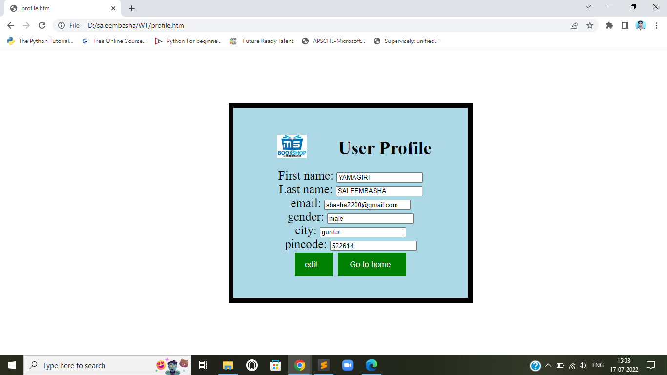

<! - - the code for above output is : - - >

<!DOCTYPE html>

<html>

<head>

<style>

.button {

background-color: green;

border: none;

color: white;

padding: 15px 32px;

text-align: center;

text-decoration: none;

font-size: 16px;

margin: 4px 2px;

padding-left:20px;

}

div{

color: black;

font-size:25px;

}

body{

padding-left: 70px;

padding-top: 100px;

}

.bor{

border: 10px solid black;

padding: 30px 10px;

width: 500px;

background-color: lightblue;

box-sizing: border-box;

}

.image{

padding-left: 80px;

padding-top: 25px;

float: left;

}

</style>

</head>

<body>

<center>

<div class="bor">

<img class="image" src="logo.jpg" width="60px" >

<h2 style="padding-left: 30px;">User Profile</h2>

<div style = "position:relative;bottom:10px;">

<form>

<label>First name:</label>

<input type="text" value="YAMAGIRI"><br>

<label>Last name:</label>

<input type="text" value="SALEEMBASHA"><br>

<label>email:</label>

<input type="text" value="sbasha2200@gmail.com"><br>

<label>gender:</label>

<input type="text" value="male"><br>

<label>city:</label>

<input type="text" value="guntur"><br>

<label>pincode:</label>

<input type="text" value="522614"><br>

<input type="button" value="edit" class="button" style="display: inline-block;">

<a href="four.htm"><input type="button" value=' Go to home' class="button"></a>

</form>

</div>

</div>

</center>

</body>

</html>

< ! - - this is code for body1.htm - - >

<!DOCTYPE html>

<html>

<head>

<style>

.button {

background-color: green;

border: none;

color: white;

padding: 15px 32px;

text-align: center;

text-decoration: none;

font-size: 16px;

margin: 4px 2px;

}

.buttonsmall{

text-align: center;

text-decoration: none;

font-size: 16px;

<!--margin: 4px 2px;-->

display: inline-block;

}

.image{

<!--padding-left: 25px;

padding-right: 15px;-->

display: inline-block;

}

</style>

</head>

<body>

<center>

<h3>book catlog:</h3>

<div class="image">

<img src="ctb.png" width="80px">

<div class="buttonsmall">

<form>

<a href="buy.htm" target="_parent"><input type="button" value="buy" ></a>

<a href="viewcart.htm" target="empty"><input type="button" value="add to cart"></a>

</form>

</div>

</div>

<div class="image">

<img src="pptb.png" width="80px">

<div class="buttonsmall">

<form>

<a href="buy.htm" target="_parent"><input type="button" value="buy" ></a>

<a href="viewcart.htm" target="empty"><input type="button" value="add to cart"></a>

</form>

</div>

</div>

<form>

<a href="orders.htm" target="empty"><input type="button" value="your orders" class="button"></a>

</form>

</center>

</body>

</html>

**output:**



< ! - - when you click on your orders button the output is : - - >

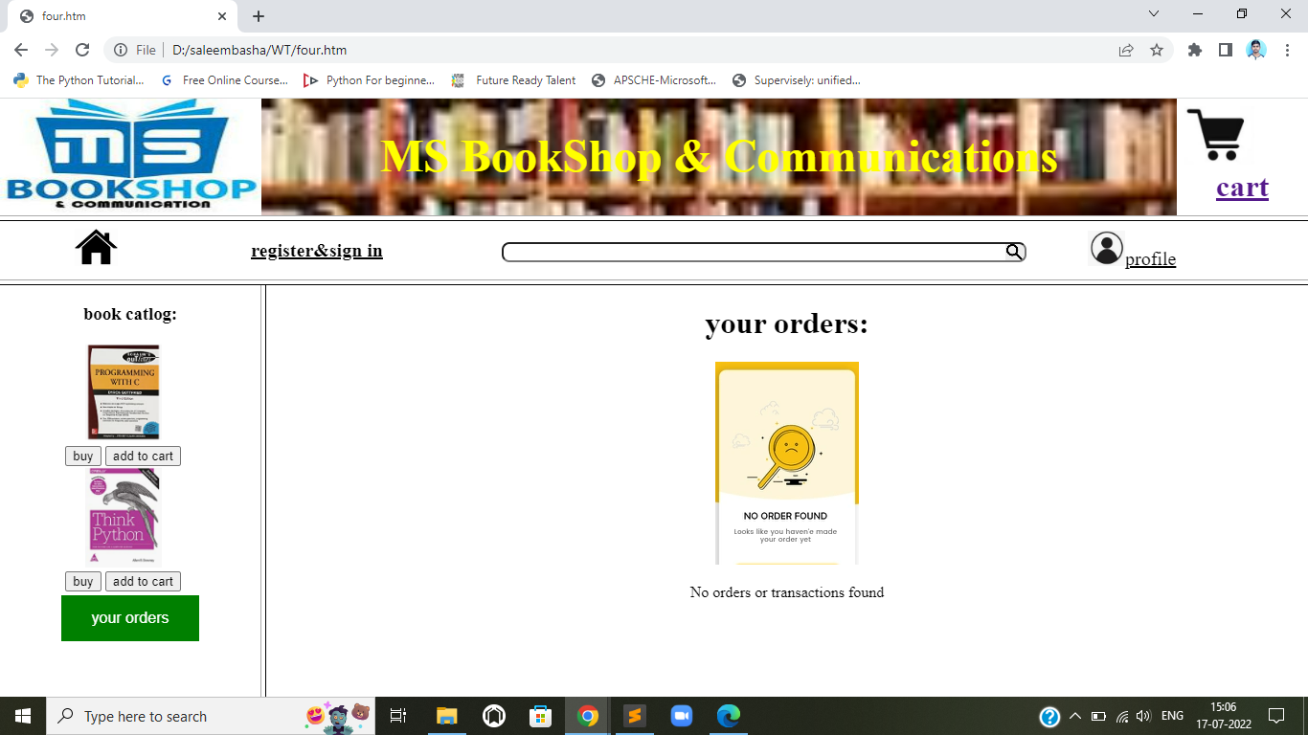

<! - - the code for above output is - - >

<!DOCTYPE html>

<html>

<body>

<center>

<h1>your orders:</h1>

<img src="noorders.png">

<p>No orders or transactions found</p>

</center>

</body>

</html>

< ! - - when you click on add to cart button the output is : - - >

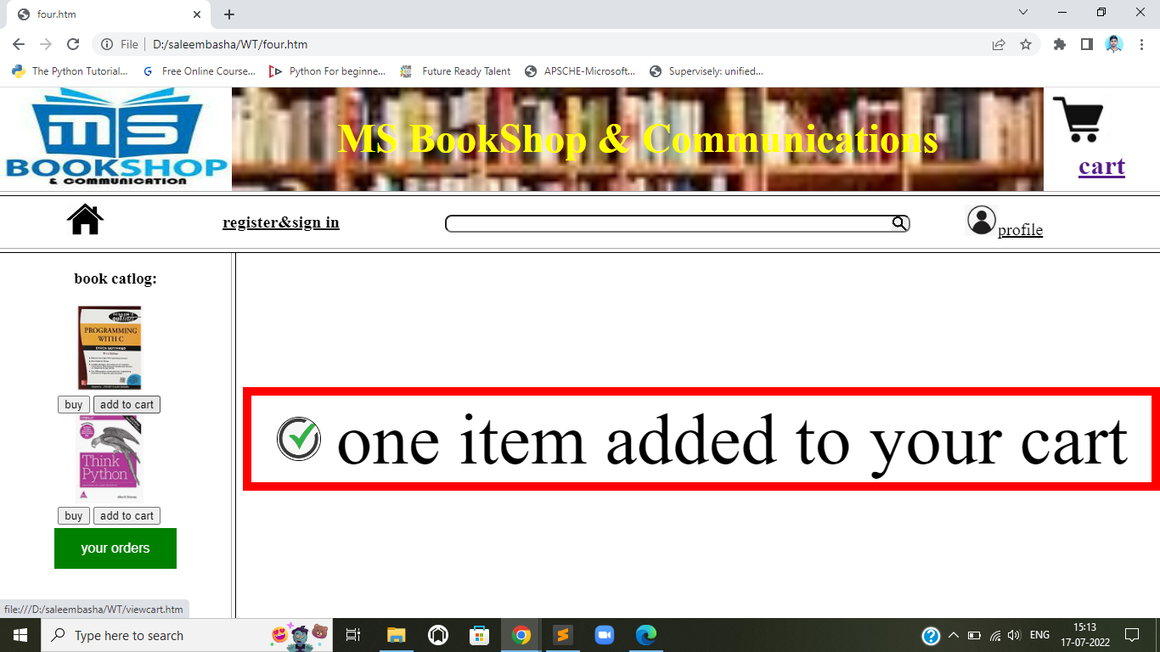

< ! - - the code for above output is: - - >

<!DOCTYPE html>

<html>

<head>

<style >

body{

padding-top: 150px;

}

.container {

padding: 2px 30px;

width: 1000px;

margin-bottom: 10px;

border: 10px solid red;

white-space: nowrap; /** force the elements to stay side by side **/

}

img {

height: 50px;

width: 50px;

border-radius: 50%;

border: 1px solid black;

vertical-align: middle

}

.text-container {

display: inline-block;

width: calc(100% - 60px); /** containers width - img width - margin-left **/

margin-left: 10px;

white-space: normal;

vertical-align: middle

}

</style>

</head>

<body>

<center>

<div class="container">

<img src="correct.png">

<div class="text-container" style="font-size: 85px">one item added to your cart</div>

</div>

</center>

</body>

</html>

< ! - - when you click on buy button the output is: - - >

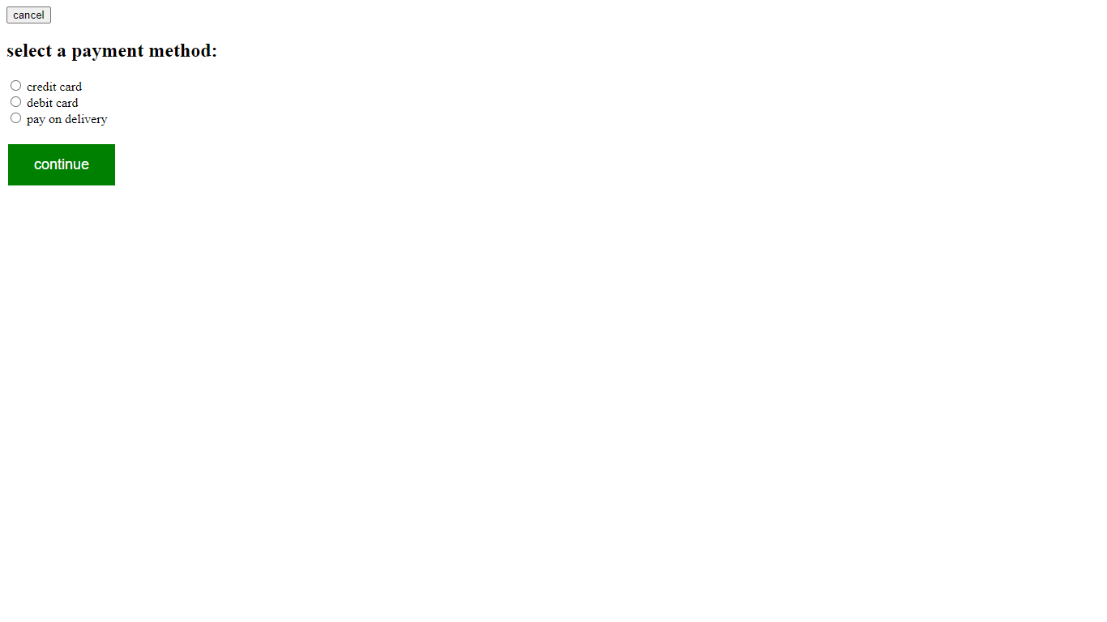

< ! - - code for above output is: - - >

<!DOCTYPE html>

<html>

<head>

<style>

.button {

background-color: green;

border: none;

color: white;

padding: 15px 32px;

text-align: center;

text-decoration: none;

font-size: 18px;

margin: 4px 2px;

}

</style>

</head>

<body>

<form>

<a href="four.htm"><input type="button" value="cancel"></a>

<label><h2>select a payment method:</h2></label>

<input type="radio">

<label>credit card</label><br>

<input type="radio">

<label>debit card</label><br>

<input type="radio">

<label>pay on delivery</label><br><br>

<a href="continue.htm"><input type="button" value="continue" class="button"></a>

</form>

</body>

</html>

< ! - - if click cancel button on top ,you will be directed to home page .then output is : - - >

< ! - - if click continue button the output is : - - >

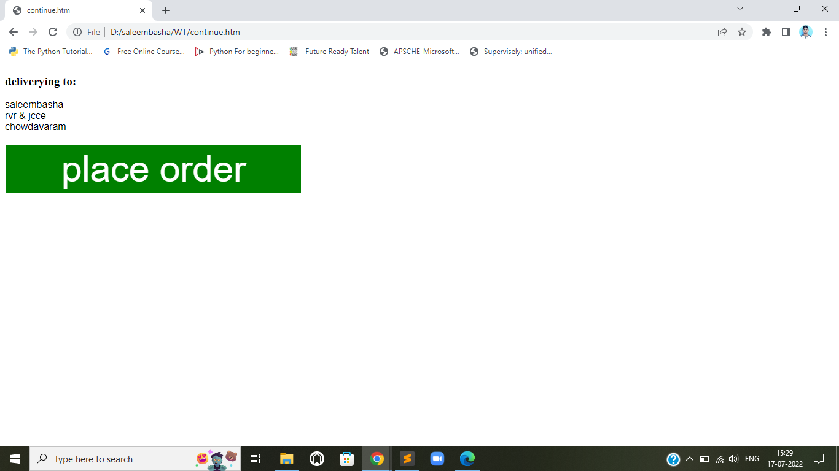

< ! - - code for above code is - - >

<!DOCTYPE html>

<html>

<head>

<style>

.button {

background-color: green;

border: none;

color: white;

padding: 5px 90px;

text-align: center;

text-decoration: none;

font-size: 60px;

margin: 4px 2px;

}

</style>

</head>

<body>

<h3>deliverying to:</h3>

<p style="font-family: arial;">saleembasha<br>rvr & jcce<br>chowdavaram</p>

<form>

<a href="confirm.htm"><input type="button" value="place order" class="button"></a>

</form>

</body>

</html>

< ! - - if you click place order button the output is : - - >

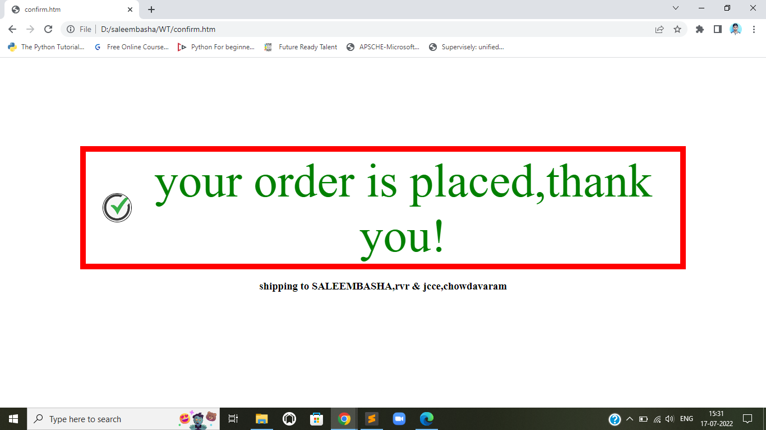

< ! - - code for above output: - - >

<!DOCTYPE html>

<html>

<head>

<style>

body{

padding-top: 150px;

}

.container {

padding: 2px 30px;

width: 1000px;

margin-bottom: 10px;

border: 10px solid red;

white-space: nowrap; /** force the elements to stay side by side **/

}

img {

height: 50px;

width: 50px;

border-radius: 50%;

border: 1px solid black;

vertical-align: middle

}

.text-container {

display: inline-block;

width: calc(100% - 60px); /** containers width - img width - margin-left **/

margin-left: 10px;

white-space: normal;

vertical-align: middle

}

</style>

</head>

<body>

<center>

<div class="container">

<img src="correct.png">

<div class="text-container" style="font-size: 85px;color: green;" >your order is placed,thank you!</div>

</div>

<h3>shipping to <b>SALEEMBASHA</b>,rvr & jcce,chowdavaram</h3>

</center>

</body>

</html>

< ! - - code for empty.htm -- >

<!DOCTYPE html>

<html>

<head>

<style>

body

{

background-image: url('emptyback.jpg');

background-repeat: no-repeat;

background-attachment: fixed;

background-size: 100% 100%;

}

</style>

</head>

<body>

</body>

</html>

**Output:**



**CSS**

**5. Write an HTML page that contains a selection box with a list of 5 countries, when the user selects a country, its capital should be printed next to the list; Add CSS to customize the properties of the font of the capital (color, bold and font size).**

<!--DOCTYPE html-->

<html>

<head>

<title>capitals of countries</title>

<style>

p{

color:red;

font-weight:bold;

font-size:50;

}

body {

background-image: url('https://img.freepik.com/free-vector/hand-painted-watercolor-pastel-sky-background_23-2148902771.jpg?w=2000');

background-repeat: no-repeat;

background-attachment: fixed;

background-size: cover;

</style>

<script language="javascript">

function capital()

{

var cunt=document.forms["frm1"].country.value;

var capital=" Please select any country ";

if( cunt=="india")

{

capital="NEW DELHI";

}

if( cunt=="china")

{

capital="BEIJING";

}

if( cunt=="pakistan")

{

capital="ISLAMABAD";

}

if( cunt=="bangladesh")

{

capital="DHAKA";

}

if( cunt=="japan")

{

capital="TOKYO";

}

if( cunt=="select")

{

capital="Please select any country";

}

document.getElementById("capt").innerHTML=capital;

}

</script>

</head>

<body>

<form name="frm1">

<br/>

<center>

<h1 style="color:red;font-size:120%">Select a Country :<select name="country" onchange="capital()"></h1>

<br>

<br>

<option value="select">--SELECT--</option>

<option value="india">INDIA</option>

<option value="china">CHINA</option>

<option value="pakistan">PAKISTAN</option>

<option value="bangladesh">BANGLADESH</option>

<option value="japan">JAPAN</option>

</select>

<br/>

<br/>

<font color="green" size="10">Capital is :</font> <p id="capt"></p>

</center>

</form>

</body>

</html>

**OUTPUT:**

